Kubernetes Task 6

- Create a ConfigMap from a directory containing multiple files and inject the variables into a pod as environment variables.
- Create a ConfigMap from a file and mount it as a volume inside a pod, ensuring the configuration data is available as files.
- Create a Secret with sensitive information (username and password) and inject it into a pod as environment variables.
- Create a Secret using a YAML file, mount it as a volume in a pod, and verify the specific Secret values are available as files.
- Inject a ConfigMap as environment variables and a Secret as files into the same pod, ensuring both are accessible within the pod.

Task 6 — Step 1
ConfigMap from a Directory → Environment Variables
Requirement
Create a directory containing multiple configuration files:
app-config/
├── APP_NAME
├── APP_ENV
└── APP_VERSION
Create a ConfigMap from that directory, then inject all those values into a Pod as environment variables.
1. Create the working directory
On your AWS server:
mkdir -p ~/k8s-task6/app-config
Enter it:
cd ~/k8s-task6
Create the three files:
echo "AquaApplication" > app-config/APP_NAME
echo "development" > app-config/APP_ENV
echo "1.0.0" > app-config/APP_VERSION
Check:
ls -l app-config
You should see:
APP_NAME
APP_ENV
APP_VERSION
Check their contents:
cat app-config/APP_NAME
cat app-config/APP_ENV
cat app-config/APP_VERSION
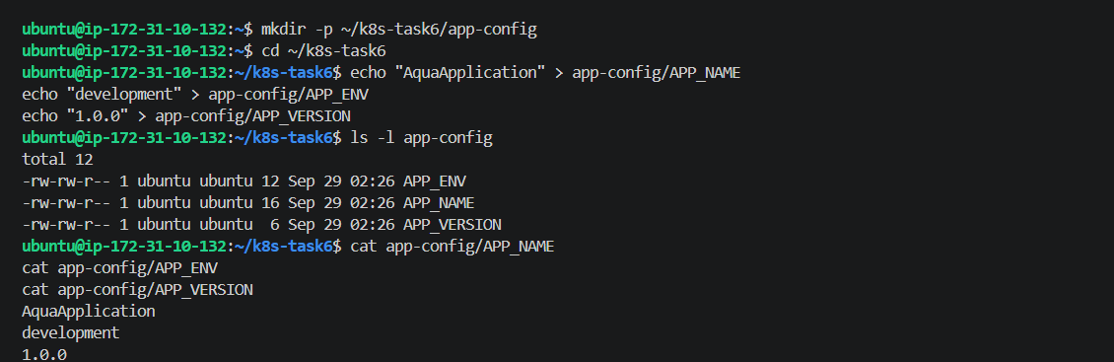
2. Create ConfigMap from the directory
Run:
kubectl create configmap app-config \
--from-file=app-config/
Expected:
configmap/app-config created
Verify:
kubectl get configmap app-config
Then:
kubectl describe configmap app-config
You should see:
Data
====
APP_NAME
----
AquaApplication

APP_ENV
----
development

APP_VERSION
----
1.0.0
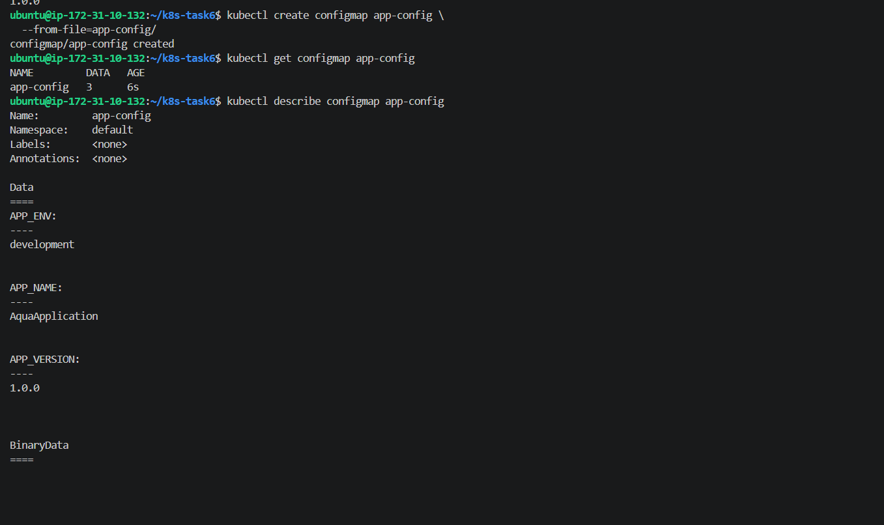
3. Create a Pod using the ConfigMap as environment variables
Create:
nano configmap-env-pod.yaml
Paste:
apiVersion: v1
kind: Pod
metadata:
name: configmap-env-pod
spec:
containers:
- name: app
image: busybox:1.36
command:
- sh
- -c
- "sleep 3600"
envFrom:
- configMapRef:
name: app-config
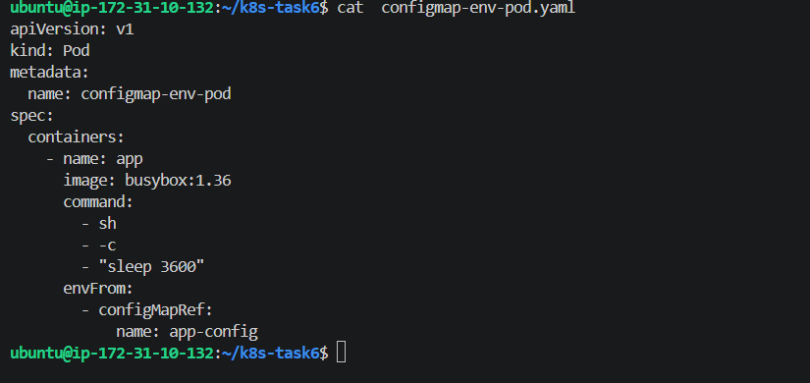
Save and apply:
kubectl apply -f configmap-env-pod.yaml
Check:
kubectl get pod configmap-env-pod
Then verify all three environment variables:
kubectl exec -it configmap-env-pod -- \
env | grep -E 'APP_NAME|APP_ENV|APP_VERSION'
Expected:
APP_NAME=AquaApplication
APP_ENV=development
APP_VERSION=1.0.0
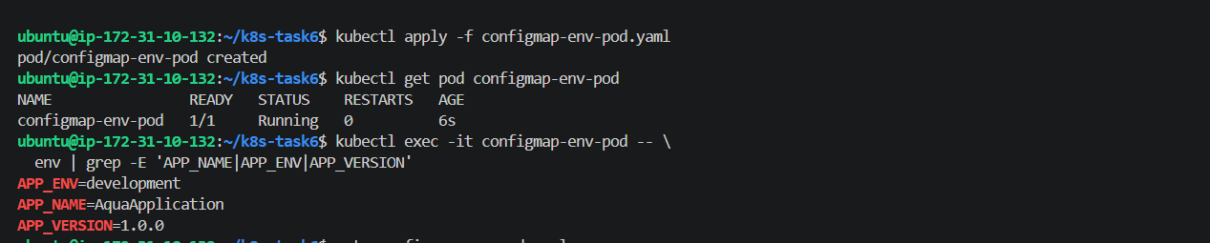
This output proves the ConfigMap values were successfully injected into the Pod as environment variables:
APP_ENV=development
APP_NAME=AquaApplication
APP_VERSION=1.0.0
And the Pod is:
configmap-env-pod 1/1 Running
Step 2 — ConfigMap from a File → Volume
Now we'll create a single configuration file, create a ConfigMap from that file, and mount it inside a Pod.
Flow
application.conf
↓
ConfigMap
↓
Volume
↓
Pod
↓
/etc/app-config/application.conf
1. Create the configuration file
You're already in:
~/k8s-task6
Run:
mkdir -p config-file
Then:
nano config-file/application.conf
Put:
APP_NAME=AquaApplication
APP_ENV=production
APP_PORT=8080
DATABASE_HOST=mysql.internal
Verify:
cat config-file/application.conf
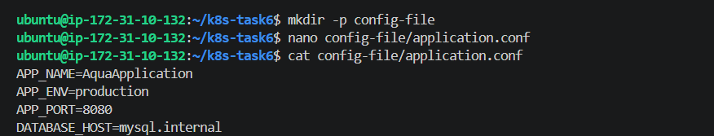

2. Create ConfigMap from the file
Run:
kubectl create configmap file-config \
--from-file=config-file/application.conf
Expected:
configmap/file-config created
Verify:
kubectl get configmap file-config
Then:
kubectl describe configmap file-config
You should see:
Data
====
application.conf:
----
APP_NAME=AquaApplication
APP_ENV=production
APP_PORT=8080
DATABASE_HOST=mysql.internal
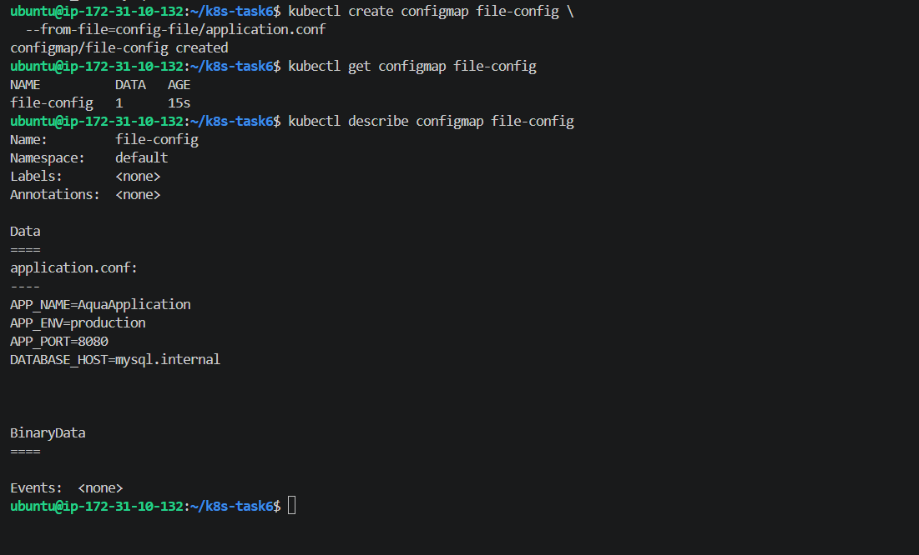
3. Create Pod and mount the ConfigMap
Create:
nano configmap-volume-pod.yaml
Paste:
apiVersion: v1
kind: Pod
metadata:
name: configmap-volume-pod
spec:
containers:
- name: app
image: busybox:1.36
command:
- sh
- -c
- "sleep 3600"
volumeMounts:
- name: config-volume
mountPath: /etc/app-config
readOnly: true
volumes:
- name: config-volume
configMap:
name: file-config
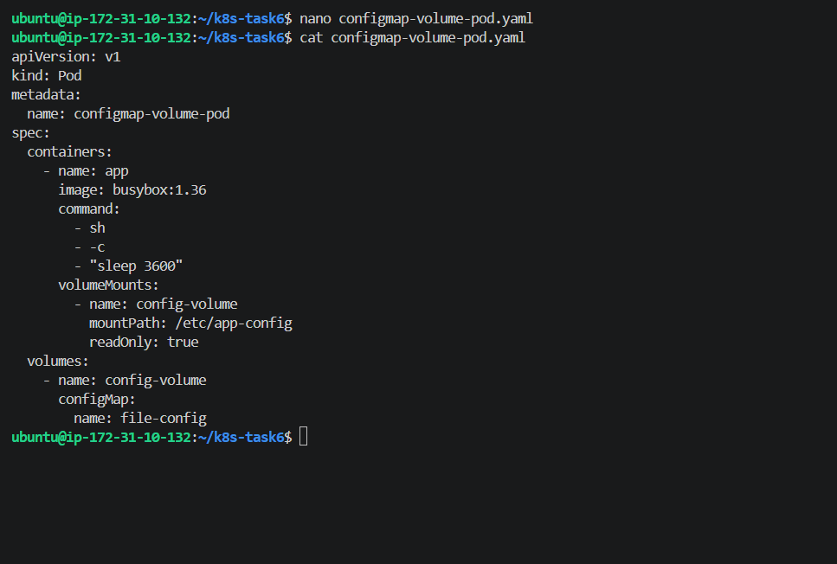
Save and apply:
kubectl apply -f configmap-volume-pod.yaml
Check:
kubectl get pod configmap-volume-pod
It should show:
configmap-volume-pod 1/1 Running
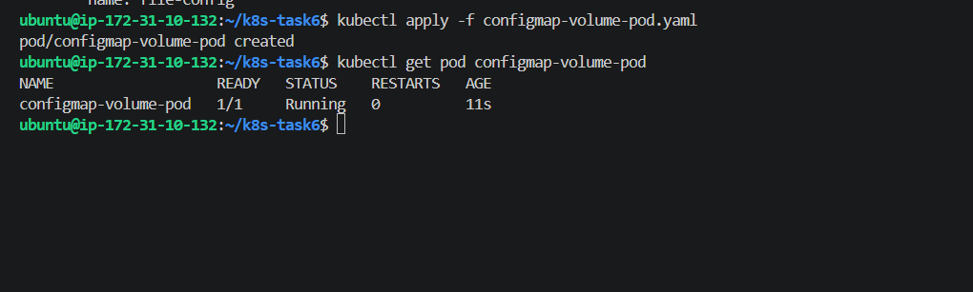
4. Verify the file inside the Pod
Run:
kubectl exec -it configmap-volume-pod -- \
cat /etc/app-config/application.conf
Expected:
APP_NAME=AquaApplication
APP_ENV=production
APP_PORT=8080
DATABASE_HOST=mysql.internal
Also verify the file exists:
kubectl exec -it configmap-volume-pod -- \
ls -l /etc/app-config
You should see:
application.conf
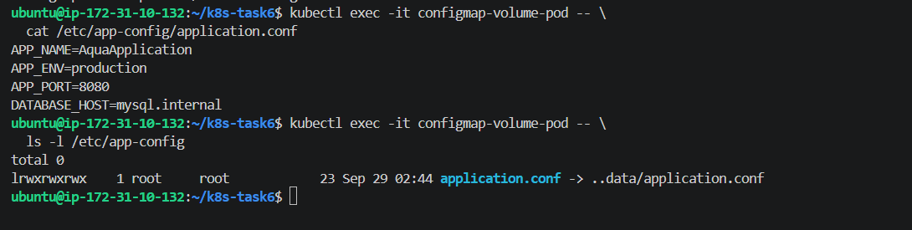
Step 3 — Secret → Environment Variables
Now we'll create a Kubernetes Secret containing:
username
password
and inject both into a Pod as environment variables.
1. Create the Secret
Since this is sensitive information, we'll create it directly using kubectl rather than putting the plain values into a YAML file.
Run:
kubectl create secret generic app-secret \
--from-literal=username=admin \
--from-literal=password='Aqua@123'
Expected:
secret/app-secret created
2. Verify the Secret exists
kubectl get secret app-secret
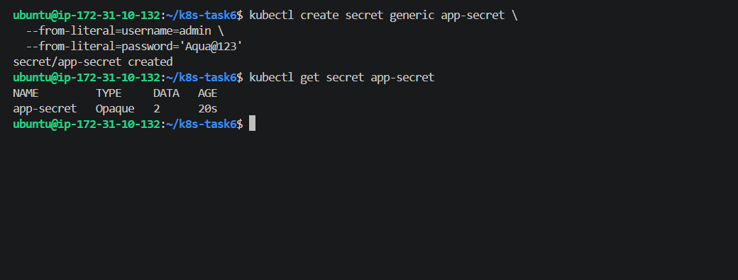
3. Create Pod using Secret environment variables
Create:
nano secret-env-pod.yaml
Paste:
apiVersion: v1
kind: Pod
metadata:
name: secret-env-pod
spec:
containers:
- name: app
image: busybox:1.36
command:
- sh
- -c
- "sleep 3600"
env:
- name: APP_USERNAME
valueFrom:
secretKeyRef:
name: app-secret
key: username
- name: APP_PASSWORD
valueFrom:
secretKeyRef:
name: app-secret
key: password

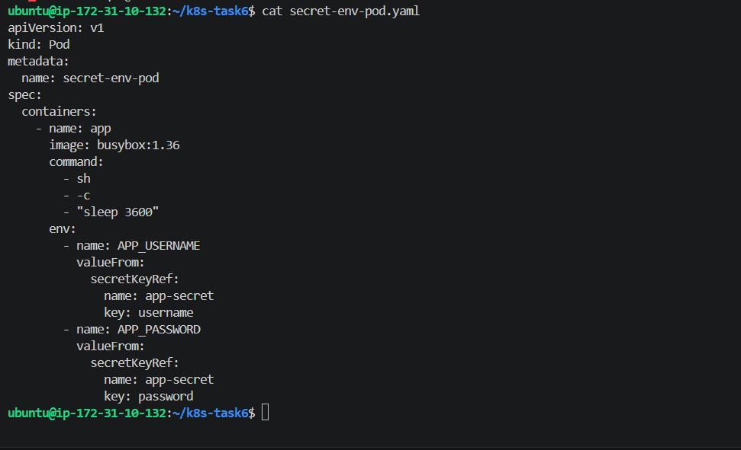
Save and apply:
kubectl apply -f secret-env-pod.yaml
Check:
kubectl get pod secret-env-pod
It should become:
secret-env-pod 1/1 Running

4. Verify the Secret values inside the Pod
Run:
kubectl exec secret-env-pod -- env | grep -E 'APP_USERNAME|APP_PASSWORD'
Expected:
APP_USERNAME=admin
APP_PASSWORD=Aqua@123
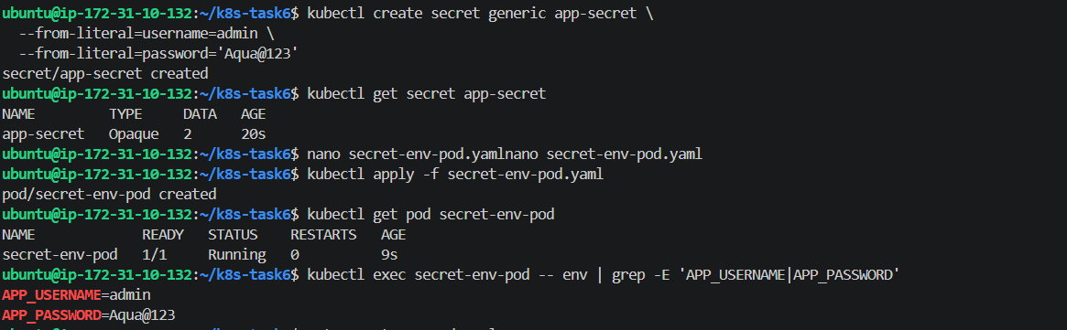
Step 4 — Secret YAML → Volume
Now we'll create the Secret using a YAML file, mount it as a volume, and verify the values appear as files inside the Pod.
For this step we'll use:
username = admin
password = Aqua@123
Because Kubernetes Secret YAML values must be base64 encoded, we'll encode them first.
1. Generate the Base64 values
Run:
echo -n 'admin' | base64
Expected:
YWRtaW4=
Then:
echo -n 'Aqua@123' | base64
Expected:
QXF1YUAxMjM=
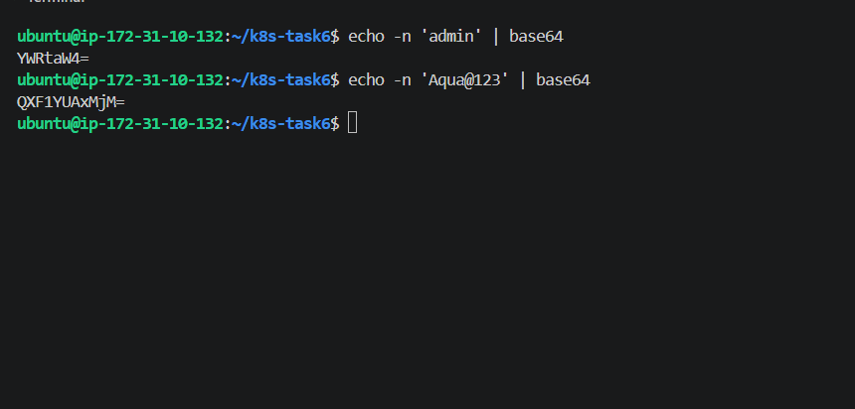
2. Create the Secret YAML
Run:
nano secret-volume.yaml
Paste:
apiVersion: v1
kind: Secret
metadata:
name: file-secret
type: Opaque
data:
username: YWRtaW4=
password: QXF1YUAxMjM=
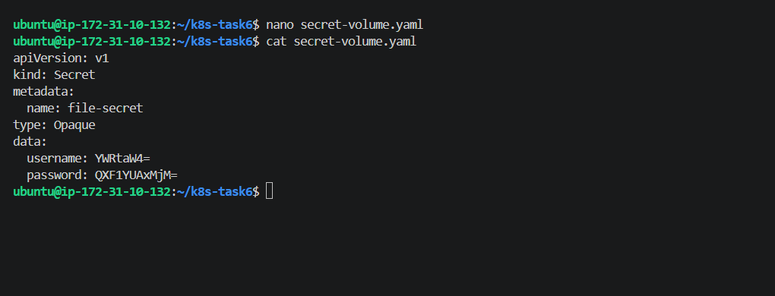
3. Apply it
kubectl apply -f secret-volume.yaml
Expected:
secret/file-secret created
Verify:
kubectl get secret file-secret
You should see:
NAME TYPE DATA AGE
file-secret Opaque 2 ...
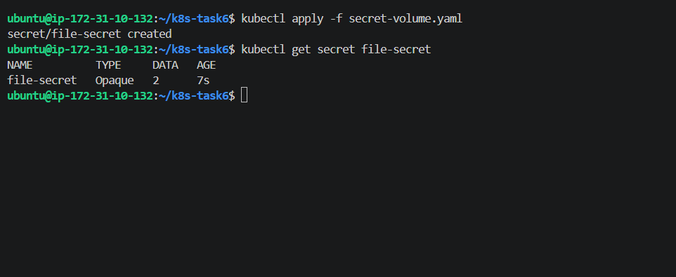
4. Create Pod with Secret volume
Create:
nano secret-volume-pod.yaml
Paste:
apiVersion: v1
kind: Pod
metadata:
name: secret-volume-pod
spec:
containers:
- name: app
image: busybox:1.36
command:
- sh
- -c
- "sleep 3600"
volumeMounts:
- name: secret-volume
mountPath: /etc/app-secret
readOnly: true
volumes:
- name: secret-volume
secret:
secretName: file-secret
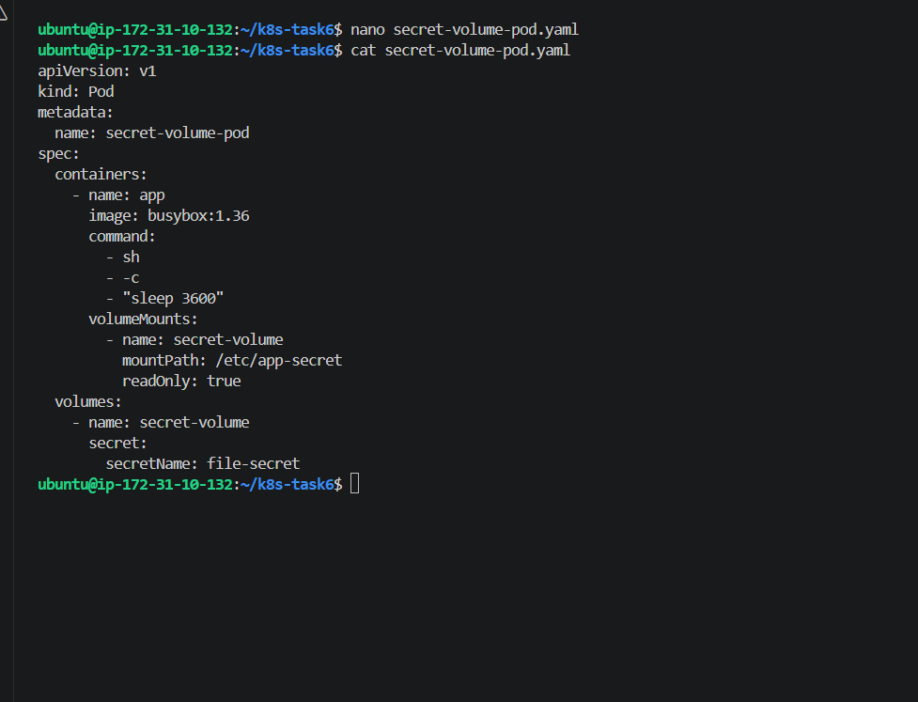
Save and apply:
kubectl apply -f secret-volume-pod.yaml
Check:
kubectl get pod secret-volume-pod
We want:
secret-volume-pod 1/1 Running
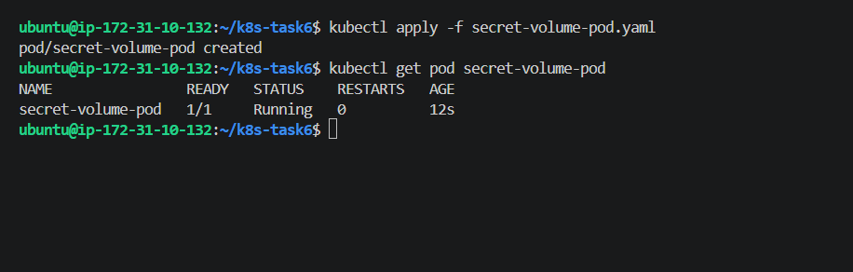
5. Verify the Secret files
List the directory:
kubectl exec secret-volume-pod -- ls -l /etc/app-secret
You should see:
password
username
Now verify the specific Secret values:
kubectl exec secret-volume-pod -- cat /etc/app-secret/username
Expected:
admin
And:
kubectl exec secret-volume-pod -- cat /etc/app-secret/password
Expected:
Aqua@123
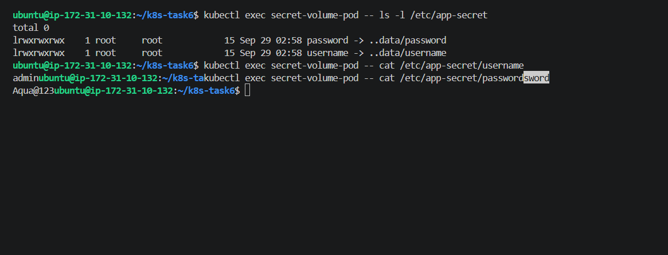

Step 5 — ConfigMap Environment + Secret Files
This is the final part of Task 6.
We need one Pod that has:
ConfigMap
↓
Environment variables

Secret
↓
Mounted files
We'll reuse the existing:
app-config
and:
file-secret
1. Create the combined Pod
Run:
cd ~/k8s-task6
nano combined-config-secret-pod.yaml
Paste this:
apiVersion: v1
kind: Pod
metadata:
name: combined-config-secret-pod
spec:
containers:
- name: app
image: busybox:1.36
command:
- sh
- -c
- "sleep 3600"

# ConfigMap → Environment Variables
envFrom:
- configMapRef:
name: app-config

# Secret → Files
volumeMounts:
- name: secret-volume
mountPath: /etc/app-secret
readOnly: true

volumes:
- name: secret-volume
secret:
secretName: file-secret
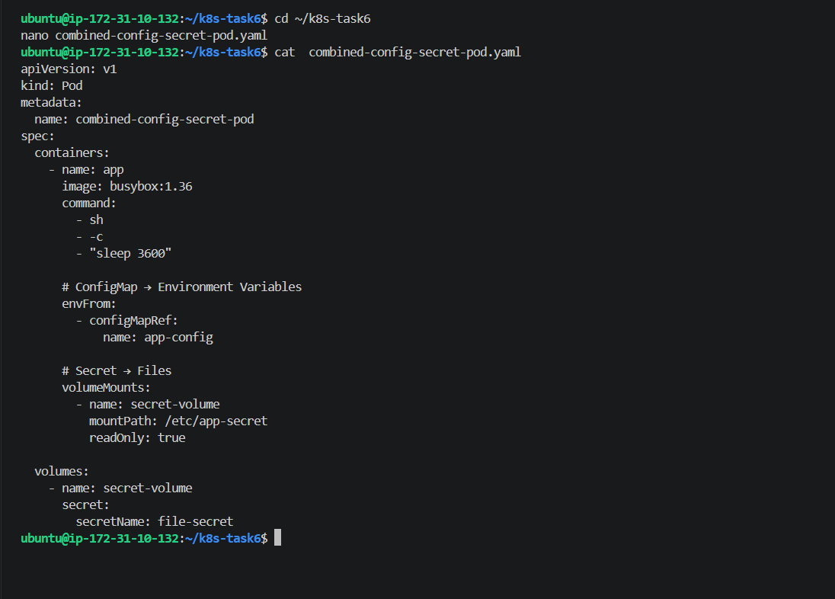
2. Create the Pod
kubectl apply -f combined-config-secret-pod.yaml
Expected:
pod/combined-config-secret-pod created
Check:
kubectl get pod combined-config-secret-pod
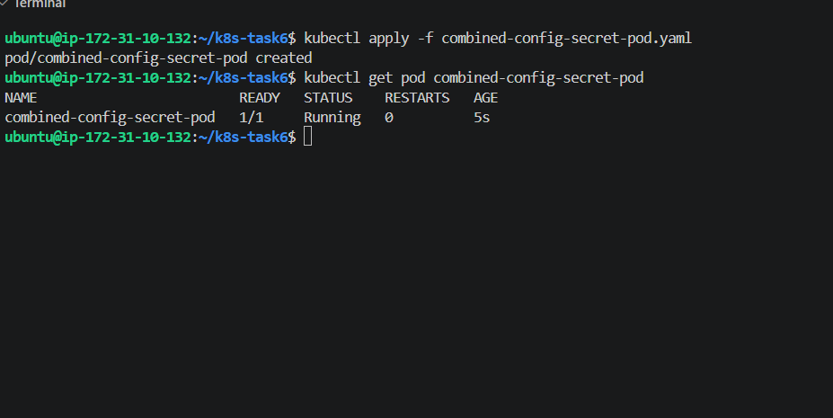
3. Verify ConfigMap Environment Variables
Run:
kubectl exec combined-config-secret-pod -- \
env | grep -E 'APP_NAME|APP_ENV|APP_VERSION'
Expected:
APP_ENV=development
APP_NAME=AquaApplication
APP_VERSION=1.0.0
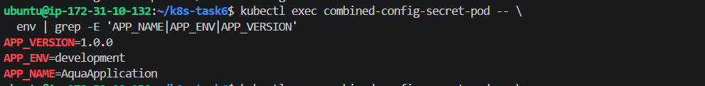
4. Verify Secret Files
List the Secret directory:
kubectl exec combined-config-secret-pod -- \
ls -l /etc/app-secret
Expected:
password
username
Check username:
kubectl exec combined-config-secret-pod -- \
cat /etc/app-secret/username
Expected:
admin
Check password:
kubectl exec combined-config-secret-pod -- \
cat /etc/app-secret/password
Expected:
Aqua@123
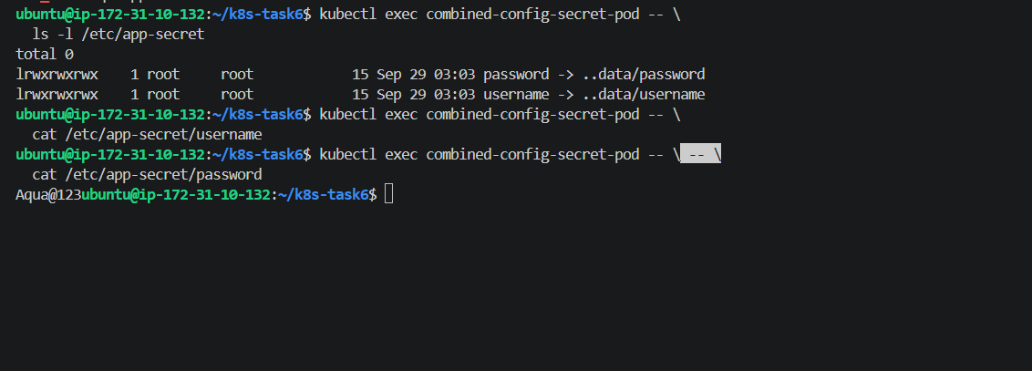
Final architecture
Once this works, you'll have demonstrated:
Kubernetes Pod
│
┌────────────┴────────────┐
│ │
ConfigMap Secret
│ │
↓ ↓
Environment Variables Volume
│ │
┌──────┼──────┐ /etc/app-secret/
│ │ │ ├── username
↓ ↓ ↓ └── password
APP_NAME APP_ENV APP_VERSION

